Project Proposal
- Title of the Project : Automobile Brand Analysis: Text Mining ( Study of Brand A compared to Brands B & C)

- Brief on the project:
Analytics objective involves in understanding the perception about the brand in the digital space, close competitor brands perception in social media, revealing insights about the brand by classifying social mentions, buzz Words used in social space to describe the brand and identifying associations & patterns in these Buzz words.

The motivation behind that problem that we find it interesting is because social media is becoming new platform for customer service and customers study reviews of a product carefully before going for any product.

- Deliverables of the project:
- List of questions your model/problem are designed to answer
The business objective involves superior brand recognition, brand loyalty, better customer service, improving market share and maintaining goodwill.
- Details of the model , important findings, expecting observations and outcome

- Sentimental Analysis
- Pattern re-cognition
- Buzz word association

- Resources
  - Data set source: The proposal should also discuss sources of real-world data for your
    - Data set provided by Aegis.
    - Data from online resources.
  - Soft ware: Software you will choose to solve the problem.
- R
- Python
- MS-PPT, MS-Excel
- Hadoop
  - References: Include 1-3 relevant papers which already discussed same/similar problems.

- http://cs229.stanford.edu/proj2014/Wen%20Zhang,%20Geng%20Zhao,%20Chenye%20Zhu,%20Mood%20Detection%20with%20Tweets.pdf

- Team Members:
Name | Email-ID | Mobile No.
Ajith Vajrala | ajith.vajrala@gmail.com | 9987014095
Basant Gupta | basant.76.gupta@gmail.com | 8377073336
Rashmi Sachan | rashmi09oct@gmail.com | 9819500751
Vivek Verma | v786.verma@gmail.com | 8767674985

- Milestones with timeline
Milestones | Start date | Finish date | Grading Grading
- Define a problem | 05/09/2016 | 17/09/2016 | 5%
- Get the Data | 09/09/2016 | 30/09/2016 | 5%
- Explore and pre-process data | 30/09/2016 | 15/10/2016 | 10%
- Create Features | 15/10/2016 | 30/10/2016 | 5%
- Create Model | 30/10/2016 | 20/11/2016 | 15%
- Deploy & consume model | 21/11/2016 | 30/11/2016 | 10%
- Report Writing | 1/12/2016 | 15/12/2016 | 10%
- Project submission | 16/01/2016 | 06/01/2017 | 15%
- Final presentation with project/ product demonstration | 07/01/2017 | 15/01/2017 | 20%
- Blog publishing | 15/01/2017 | 24/01/2017 | 5%
*Refer Data Science Process Doc – if deadline is missed no weightage will be given and it will entail loss of grade for the group. All milestones should be submitted online as per date indicated by the group.

- Technical architecture
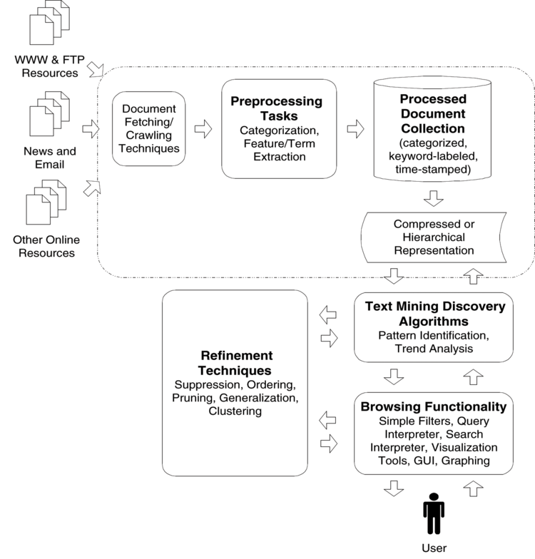

Source: The Text Mining Handbook By: Ronen Feldman; James Sanger

